Practical Information for the EPSSE 2024
Preconference Workshop (June 18) and Conference (June 19-21)

Universidade de Lisboa, Universidade Nova de Lisboa, Lisboa-Portugal

HOTEL

June is a busy time, book your hotel as early as possible. When choosing the hotel, it may be good to know that both the pre-conference workshop and the first day of main conference will take place at Faculdade de Letras da Universidade de Lisboa, located at Alameda da Universidade, Lisboa 1600-214 Lisboa (1st VENUE), while the second and third day of the conference will take place in Faculdade de Ciências Sociais e Humanas da Universidade nova de Lisboa Located at Av. Berna 26 (2st VENUE)

The suggested hotels are the following:

Closer to 1st Venue

Masa hotel Campo Grande
https://www.masahotels-lisboncollection.com/pt/about-hotel

Hotel NH Lisboa Campo Grande
https://www.nh-hotels.com/en/hotel/nh-lisboa-campo-grande?utm_campaign=local-gmb&utm_medium=organic_search&utm_source=google_gmb

Closer to 2nd Venue
Hotel Príncipe Lisboa
https://www.hotelprincipelisboa.com/en/
Metro just outside (11m walking distance from 2nd Venue)

SANA Reno
https://www.sanahotels.com/en/hotel/sana-reno/
Metro just outside (11m walking distance from 2nd Venue)

In between the two:

VIP Executive Zurique Hotel
https://www.vipzuriquehotel.com/

VIP Executive Entrecampos Hotel & Conference
https://www.vipentrecamposhotel.com/en/m2/

VIP Grand Lisboa Hotel & Spa
https://www.vipgrandlisboahotel.com

CONFERENCE LOCATION

Location for both the pre-conference workshop and the first day of main conference will take place at Faculdade de Letras da Universidade de Lisboa, located at Alameda da Universidade, Lisboa 1600-214 Lisboa (1st VENUE)
https://www.ulisboa.pt/unidade-organica/faculdade-de-letras

Rooms are located on the 2nd floor: C250, C251A and C251B.

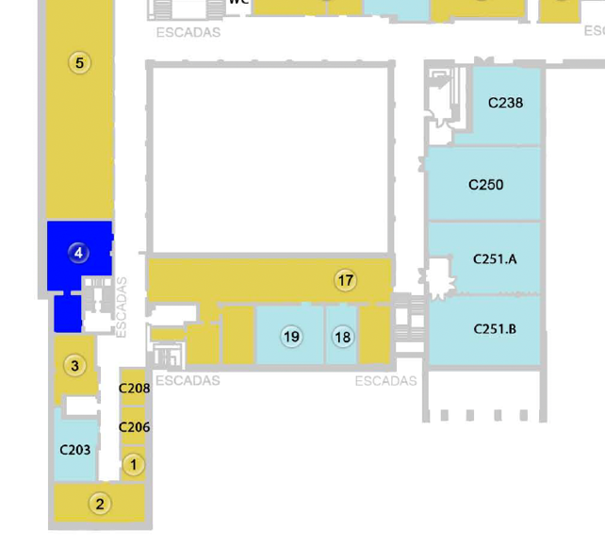

The closest metro station to 1nd Venue is Cidade Universitária (yellow line)
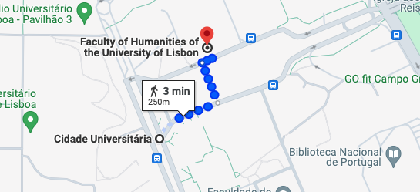

2nd VENUE
Second and third day of the conference will take place in Faculdade de Ciências Sociais e Humanas da Universidade nova de Lisboa Located at Av. Berna 26 (2st VENUE)
https://www.google.pt/maps/place/Faculdade+de+Ci%C3%AAncias+Sociais+e+Humanas+da+Universidade+NOVA+de+Lisboa/@38.7402317,-9.1491824,816m/data=!3m1!1e3!4m6!3m5!1s0xd19330ec7910bd3:0x7724c2297e204d25!8m2!3d38.7406173!4d-9.1506489!16s%2Fm%2F0g9t96f?hl=pt-PT&entry=ttu

Faculdade de Ciências Sociais e Humanas da Universidade Nova de Lisboa
Avenida de Berna, 26-C 1069-061 Lisboa (entrance looks like this)
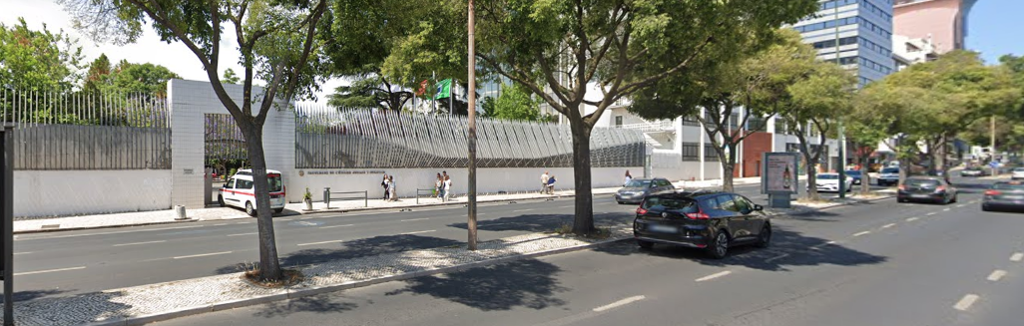

and the conference rooms are on EDIFICIO B on the 3rd floor (on the right after the main gate) which looks like this

The general location of 2nd Venue in relation to the two closest metro stations

Image from Metro Station Campo Pequeno (yellow line) to Uni
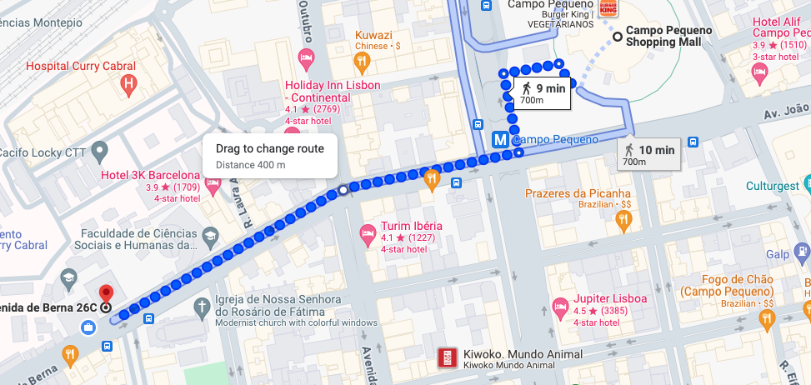

Image from Metro Station S.Sebastião (blue line) to Uni

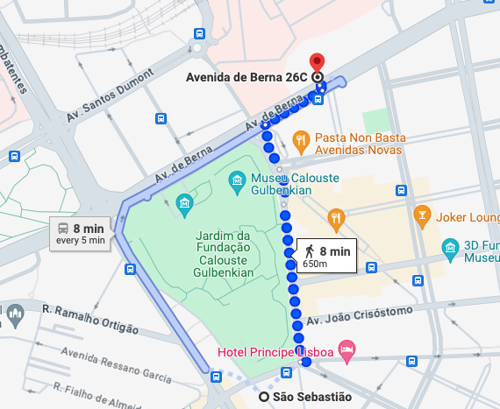
Some of the hotels listed are closer to one of the universities or closer to the other and a third list of suggestions is more and less in the middle between them.

GETTING TO THE VENUE

From the airport (which is very close to the city and both venues):
By metro: get at the airport (red line) until Saldanha (direction S. Sebastião), and then at Saldanha get yellow line to Cidade Universitária (direction Odivelas)
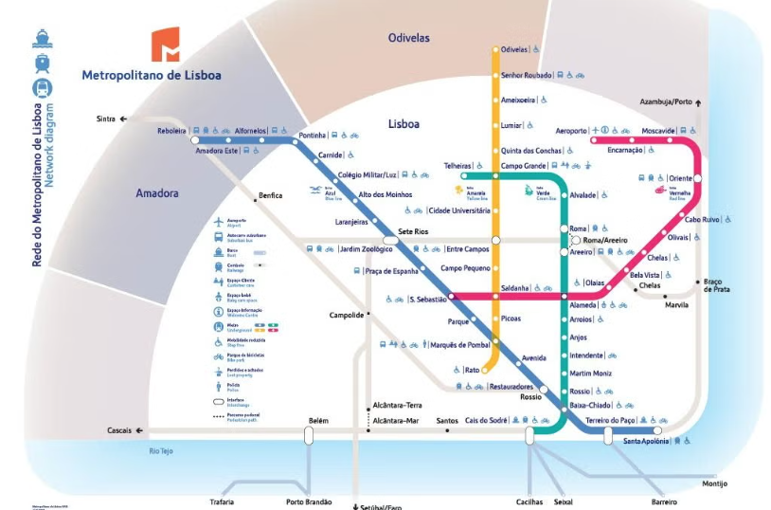

By Taxi: There is a taxi line outside of the airport on arrivals. Sometimes it can get really busy but the line moves reasonably fast.It can cost around 35€ to the city center and at takes about 20m.

GETTING AROUND IN LISBON

Bolt/Uber and taxis
It is possible to use both Bolt app https://bolt.eu/en/cities/lisbon/
or Uber App https://www.uber.com/global/en/cities/lisbon/

For a taxi service:
You can find many taxi stands in Lisbon and Hotels will call one for you if needed.
If you want you can also reach them by calling either:
Radio Taxis (+351 218119000 OR +351 969531660 Or +351 919781000) (they have calllers who speak English)
Or
Coop Taxis (+351 7932756)

Public transport:
Lisbon Subway city is easy to understand and a map and other info can be found at https://www.metrolisboa.pt/en/
If you purchase a 7Colinas Card 7 Colinas Card ((you can purchase it at ticket machines in the metro stations (€.50) you can easily get around the city in its public transports.
The ticket can be charged with different values from individual trips (€1.80 each) to a 1-day ticket (24 h for €6.80 which is valid for metro and buses) or opt for a zapping mode in which individual trips are cheaper (€1.61)

Scooters look at “A quick Guide to Using Eletric Scooters in Lisbon” https://www.triptipedia.com/tip/EbXY3yn/a-quick-guide-to-using-electric-scooters-in-lisbon-elsewhere

More general info about Lisbon can be found in
https://www.lisbon.net/general-information Where you can find info such as “How to Get to the city center from the Airport”, Places to eat, where to stay, etc.

